**ENGLISH 2° EXTRAORDINARY EXAM**

**STUDY GUIDE**

**•NATIONALITIES. Match the country with the corresponding nationality and make a drawing of 5 of them.** (Relaciona en país con la nacionalidad correspondiente y realiza un dibujo de 5 de ellas.)

|  |  |
| --- | --- |
| COUNTRIES | NATIONALITIES |
| 1. TURKEY 2. GERMANY 3. RUSSIA 4. AUSTRALIA 5. USA 6. BRAZIL 7. FRANCE 8. UK 9. ITALY 10. GEEECE 11. SPAIN 12. PORTUGAL 13. ISRAEL 14. CHINA 15. JAPAN 16. CANADÁ | _____ SPANISH  _____ ITALIAN  _____ AMERICAN  _____ CHINESE  _____ ENGLISH  _____ TURKISH  _____ CANADIAN  _____ GERMAN  _____ JAPANESE  _____ BRAZILIAN  _____ PORTUGUESE  _____ RUSSIAN  _____ FRENCH  _____ GREEK  _____ ISRAELI  _____ AUSTRALIAN |

**DRAWINGS:**

•**CULTURAL ASPECTS. Find the indicated words in each wordsearch and make a drawing of 5 words for each wordsearch.** (Encuentra las palabras indicadas en cada sopa de letras y realiza un dibujo para 5 palabras de cada sopa de letras.)

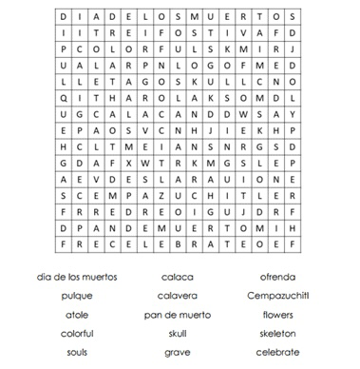**DAY OF THE DEAD**

**DRAWINGS:**

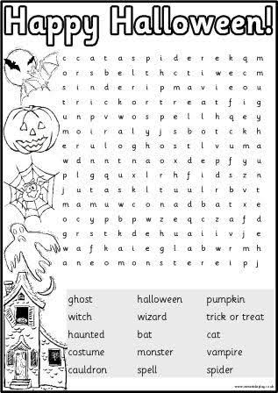

**DRAWINGS**:

• **RISKY SITUATIONS.** **Read the sentences and tips and write them in the correct poster.** (Lee las oraciones y consejos y escríbelos en el cartel correcto.)

1.- Tip: If you are scared, it´s OK. Talk to an adult about it.

2.- Turn off gas, water, and electricity supplies.

3.- Protect children. Keep them away from Windows.

4.- Bring your toys inside the house. They can fly away with the wind and hit people!

5.- Tip: If you don´t have shutters for your windows, protect them with boards.

6.- Don´t explore outside without permission. Cool kids take good care!

